Self join

1. select count(*) from stops

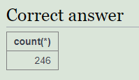

1. select id from stops where name = 'Craiglockhart'

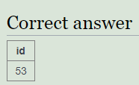

1. select id, name from stops INNER JOIN route ON (stops.id = route.stop) where company = 'LRT' and num = 4

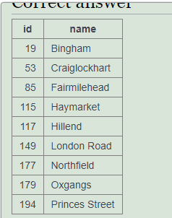

1. SELECT company, num, COUNT(*) FROM route WHERE stop=149 OR stop=53 GROUP BY company, num HAVING COUNT(*) > 1

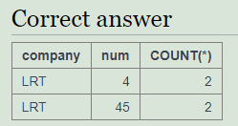

1. SELECT a.company, a.num, a.stop, b.stop FROM route a JOIN route b ON (a.company=b.company AND a.num=b.num) WHERE a.stop=53 and b.stop = 149

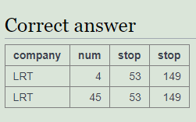

1. SELECT a.company, a.num, stopa.name, stopb.name

FROM route a JOIN route b ON

(a.company=b.company AND a.num=b.num)

JOIN stops stopa ON (a.stop=stopa.id)

JOIN stops stopb ON (b.stop=stopb.id)

WHERE stopa.name='Craiglockhart' and stopb.name='London Road'

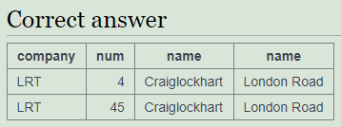

1. SELECT distinct a.company, a.num

FROM route a JOIN route b ON

(a.company=b.company AND a.num=b.num)

WHERE a.stop=115 and b.stop = 137

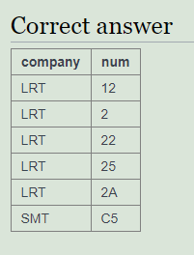

1. select a.company, a.num

from route a INNER JOIN route b ON (a.company= b.company)

INNER JOIN stops c ON (a.num = c.id and b.num = c.id)

where a.stop = 53 and b.stop = 230

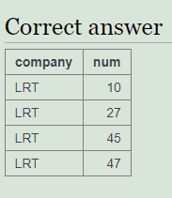

1. select DISTINCT c.name, a.company, a.num

from route a JOIN route b ON (a.company = b.company and a.num = b.num)

JOIN stops c ON (a.stop = c.id)

where b.stop = 53

|  |  |  |
| --- | --- | --- |
| **name** | **company** | **num** |
| Silverknowes | LRT | 10 |
| Muirhouse | LRT | 10 |
| Newhaven | LRT | 10 |
| Leith | LRT | 10 |
| Leith Walk | LRT | 10 |
| Princes Street | LRT | 10 |
| Tollcross | LRT | 10 |
| Craiglockhart | LRT | 10 |
| Colinton | LRT | 10 |
| Torphin | LRT | 10 |
| Silverknowes | LRT | 27 |
| Crewe Toll | LRT | 27 |
| Canonmills | LRT | 27 |
| Hanover Street | LRT | 27 |
| Tollcross | LRT | 27 |
| Craiglockhart | LRT | 27 |
| Oxgangs | LRT | 27 |
| Hunters Tryst | LRT | 27 |
| Bingham | LRT | 4 |
| Northfield | LRT | 4 |
| London Road | LRT | 4 |
| Princes Street | LRT | 4 |
| Haymarket | LRT | 4 |
| Craiglockhart | LRT | 4 |
| Oxgangs | LRT | 4 |
| Fairmilehead | LRT | 4 |
| Hillend | LRT | 4 |
| Brunstane | LRT | 45 |
| Duddingston | LRT | 45 |
| Northfield | LRT | 45 |
| London Road | LRT | 45 |
| Hanover Street | LRT | 45 |
| Tollcross | LRT | 45 |
| Craiglockhart | LRT | 45 |
| Colinton | LRT | 45 |
| Currie | LRT | 45 |
| Riccarton Campus | LRT | 45 |
| Canonmills | LRT | 47 |
| Hanover Street | LRT | 47 |
| Tollcross | LRT | 47 |
| Craiglockhart | LRT | 47 |
| Colinton | LRT | 47 |
| Currie | LRT | 47 |
| Balerno | LRT | 47 |
| Cockburn Crescent | LRT | 47 |
| Balerno Church | LRT | 47 |

1. SELECT a.num, a.company, stopb.name, c.num, c.company

FROM route a

JOIN route b ON (a.company = b.company AND a.num = b.num)

JOIN (route c JOIN route d ON (c.company = d.company AND c.num = d.num))

JOIN stops stopa ON a.stop = stopa.id

JOIN stops stopb ON b.stop = stopb.id

JOIN stops stopc ON c.stop = stopc.id

JOIN stops stopd ON d.stop = stopd.id

WHERE stopa.name = 'Craiglockhart'

AND stopd.name = 'Lochend'

AND stopb.name = stopc.name

ORDER BY LENGTH(a.num), b.num, stopb.name, LENGTH(c.num), d.num;

|  |  |  |  |  |
| --- | --- | --- | --- | --- |
| **num** | **company** | **name** | **num** | **company** |
| 4 | LRT | Haymarket | 65 | LRT |
| 4 | LRT | Haymarket | C5 | SMT |
| 4 | LRT | London Road | 20 | LRT |
| 4 | LRT | London Road | 34 | LRT |
| 4 | LRT | London Road | 35 | LRT |
| 4 | LRT | London Road | 42 | LRT |
| 4 | LRT | London Road | 65 | LRT |
| 4 | LRT | London Road | 87 | LRT |
| 4 | LRT | London Road | C5 | SMT |
| 4 | LRT | London Road | 46A | LRT |
| 4 | LRT | London Road | 87A | LRT |
| 4 | LRT | Princes Street | 65 | LRT |
| 4 | LRT | Princes Street | C5 | SMT |
| 10 | LRT | Leith | 34 | LRT |
| 10 | LRT | Leith | 35 | LRT |
| 10 | LRT | Leith | 87 | LRT |
| 10 | LRT | Leith | C5 | SMT |
| 10 | LRT | Princes Street | 65 | LRT |
| 10 | LRT | Princes Street | C5 | SMT |
| 27 | LRT | Canonmills | 34 | LRT |
| 27 | LRT | Canonmills | 35 | LRT |
| 27 | LRT | Crewe Toll | 20 | LRT |
| 45 | LRT | Duddingston | 42 | LRT |
| 45 | LRT | Duddingston | 46A | LRT |
| 45 | LRT | London Road | 20 | LRT |
| 45 | LRT | London Road | 34 | LRT |
| 45 | LRT | London Road | 35 | LRT |
| 45 | LRT | London Road | 42 | LRT |
| 45 | LRT | London Road | 65 | LRT |
| 45 | LRT | London Road | 87 | LRT |
| 45 | LRT | London Road | C5 | SMT |
| 45 | LRT | London Road | 46A | LRT |
| 45 | LRT | London Road | 87A | LRT |
| 45 | LRT | Riccarton Campus | 65 | LRT |
| 47 | LRT | Canonmills | 34 | LRT |
| 47 | LRT | Canonmills | 35 | LRT |

Clear your results